SECTION 26 09 XX
LIGHTING CONTROL SYSTEM or NETWORK LIGHTING CONTROL SYSTEM (NLCS)
- GENERAL
  - Summary
    - Provide Architectural Dimming and Control equipment as specified herein and as shown on the schedules and drawings.
    - Prime electrical contractor shall connect power feed and load circuits to the new dimming and control system.
    - Related Sections:
      - Section 01 70 00 Execution and Closeout Requirements
      - Section 11 61 00 Broadcast, Theatre, and Stage Equipment
      - Section 26 08 00 Commissioning of Electrical Systems
      - Section 26 09 00 Instrumentation and Control for Electrical Systems
      - Section 26 50 00 Lighting
        - Section 26 51 00 Interior Lighting
        - Section 26 55 00 Special Purpose Lighting
        - Section 26 56 00 Exterior Lighting
(Edit /Delete above list of Sections as necessary).

  - Administrative Requirements
    - Preconstruction Evaluation: Refer to Division 01 requirements.
    - Project Meetings: Refer to Division 01 requirements.
    - Construction Documentation: Refer to Division 01 requirements.
    - Special Administrative Requirements: Refer to Division 01 requirements.

  - References and Standards
    - Abbreviations and Acronyms: Refer to Section 01 42 13
    - Standards listed by reference, including revisions by issuing authority, form a part of this specification section to extent indicated.
    - Standards listed are identified by issuing authority, authority abbreviation, designation number, title, or other designation established by issuing authority.
    - Standards subsequently referenced herein are referred to by issuing authority abbreviation and standard designation.
    - Reference Standards: Refer to Section 01 42 19 and in addition may include but are not limited to the following:
      - Underwriters Laboratories (UL)
        - UL 508 Industrial Control Equipment
        - UL 508a Industrial Control Panels
        - UL 891 Dead-Front Switchboards
        - UL 916 Energy Management Equipment
        - UL 2043 Standard for Safety Fire Test for Heat and Visible Smoke Release
      - ANSI/ESTA American National Standards Institute
        - ANSI/NFPA 70 The National Electrical Code®
        - ANSI E1.11–2008 (R2013) Entertainment Technology - USITT DMX512-A, Asynchronous Serial Digital Data Transmission Standard for Controlling Lighting Equipment and Accessories
        - ANSI E1.17–2015 Entertainment Technology - Architecture for Control Networks (ACN)
        - ANSI E1.31-2016 Entertainment Technology - Lightweight Streaming Protocol for Transport of DMX512 using ACN
        - ANSI E1.27–1-2006 (R2016) Entertainment Technology - Standard for Portable Control Cables for Use with USITT DMX512/1990 and E1.11 (DMX512-A) Products
        - ANSI E1.27-2–2009 (R2014) Entertainment Technology - Recommended Practice for Permanently Installed Control Cables for Use with ANSI E1.11 (DMX512-A) and USITT DMX512/1990 Products
      - ANSI/NEMA
        - ANSI/NEMA C82.11-2011 High Frequency Fluorescent Lamp Ballasts - Annex A Low Voltage Control Interface for Controllable Ballasts.
      - ANSI TIA/EIA
        - TIA-232-F - Interface Between Data Terminal Equipment and Data Circuit-Terminating Equipment Employing Serial Binary Data Interchange.
        - TIA-485-A - Electrical Characteristics of Generators and Receivers for Use in Balanced Digital Multipoint Systems
      - Institute of Electronic and Electrical Engineers (IEEE)
        - IEEE 802.3 CSMA/CD (ETHERNET)
    - All products with power terminals wiring directly to power systems or branch circuits above 49 Volts AC shall be Listed or Recognized as applicable by a Nationally Recognized Testing Laboratory (NRTL).
    - All products shall conform to International Committee on Electromagnetic Safety (ICES) and FCC Part 15 for electronic emissions.
    - Custom field assemblies shall meet all applicable codes and where local jurisdictions require, shall be inspected, and approved by the local code authority at Division 26 installer’s expense.

  - Temporary Facilities and Controls
    - Temporary Use of Permanent Work: Refer to Division 01 requirements.
    - Additional to Division 01 requirements, use of devices provided under this section shall require the contractor to clean and refurbish item(s) to “as new out of box” condition.

  - Protection and Cleaning
    - Storage and Protection: Store materials protected from exposure to harmful environmental conditions and at temperature & humidity conditions recommended by the manufacturer.
    - Touch up, repair, or replace damaged components before Substantial Completion.
    - Remove temporary tags, coverings, & construction debris from interior and exterior surfaces of equipment. Remove construction debris from equipment area & dispose of debris.
    - Clean integral air filters, heat sinks, grills, and fans before Substantial Completion and Commissioning Services.

  - Warranty
    - Signify Lighting warrants that its products (other than ballasts) are free of defects in workmanship and materials for a period of three (3) years from the date of shipment with an option to extend the warranty period to up to five (5) years.
    - The manufacturer shall provide a single source warranty for all supplied equipment specified in this section.
    - At its sole option, the manufacturer will repair or replace any supplied product defective in workmanship or materials.
    - Signify Lighting will not be responsible for any products subjected to inappropriate application, installed, or modified in any way that is not in accordance with Signify Lighting’s instructions.
    - Warranty service shall be defined as any failure to equipment during standard operation as defined by the equipment’s specification or user guide.
- PRODUCTS
  - Product Summary
    - Architectural Lighting Dimming and Control Equipment utilizing centralized and local dimmers, centralized and device processor control, devices to provide conditional and situational data for use by the Network Lighting Control System (NLCS).
    - Installing contractor shall receive, place, connect, and mount all equipment specified in this Section per the manufacturer’s instructions.
    - Installing contractor shall furnish all hardware, wire, conduit, connectors, and other necessary items as required for a complete and functional lighting control system.

  - Acceptable Manufacturers
    - Signify
      - Address: 400 Crossing Blvd, Bridgewater, NJ 08807
      - Telephone: 800.372.331 (eastern time zone)
      - Website: https://dynalite.com/
    - The listing of a manufacturer as acceptable does not imply automatic approval. It is the sole responsibility of the electrical contractor to ensure compatibility of submitted products to other sections of the specification.
    - Substitutions: No substitutions permitted. Any substitutions shall be at the electrical contractor’s expense including design modifications or compatibility complications that may arise from acceptance of unapproved substitutions.
    - Pre-bid approval of substitute product manufacturers does not relieve the contractor and the product manufacturer from compliance with the functional and operational requirements of the Specifications. All products will be carefully evaluated during the submittal review process. If, at that time, any pre-bid approved substitute is found to be unsatisfactory and not in compliance, the contractor then must re-submit and supply the specified product(s) without additional costs to the Owner and/or delay to project.
    - Alternate manufacturer(s) shall furnish a one-line system drawing of the system design upon bid proposal.

  - Manufacturer Qualifications
    - Manufacture shall have greater than 100 years of lamp and electrical manufacturing experience.
    - Perform controls manufacturing, sales, and warranty support with fulltime service personal employed by the manufacturer in the United States and Canada.
    - Shall have the ability to package lighting controls, fixtures, lamps, and drivers (ballasts) from a single manufacturer and distribute shades and shade control from a qualified third party.

  - Design
    - Alternate manufacturer(s) shall furnish a one-line system drawing of the system design upon bid proposal.
    - Upon completion of project the manufacturer shall furnish as-built one-line system drawings and all pertinent instruction manuals and datasheets to the end user within 120 days of signed completion of the project by the owner or owner’s representative.
    - Should commissioning be required per contract, end user training of the maintenance and operation of the equipment shall be provided by the manufacture or manufacturer’s representative following the completion of the commissioning of the project (per contract specification).

  - System Architecture
    - The Network Lighting Control System (NLCS) shall support direct communication between all devices via a distributed control architecture. For example, user interfaces must be able to communicate directly with load controllers, without the need for routing via a central processing unit or subnetwork. This is required to avoid single points of failure, excessive network traffic, repetitive messaging, or overly complex network topology. Control systems that require a central processing unit shall not be accepted. Control system network communications should be streamlined and allow for a single instruction from and to any network device.
    - Systems that depend on load controllers connecting to a subnetwork from a ‘master’ gateway controller shall not be accepted as there is a single point of failure, repetitive networking messages, and complexity in multiple protocols.
    - All network devices (controllers, UIs, sensors, etc.) within the system shall utilize the same communication protocol. Systems that do not utilize a single core protocol, or depend on a site's Ethernet LAN to pass messages between devices, shall not be accepted. This reduces dependence on bridging gateways, potential points of failure, and unnecessary network complexity.
    - The control system shall achieve the required functionality by using a distributed intelligence across all network architecture. In the event of a severed cable or similar network outage, the system must automatically continue operation as two independent lighting control networks. Systems that require operator intervention or cease any local operation in the event of a network cable cut shall not be accepted.
Example of an acceptable system architecture where all devices communicate directly with each other.
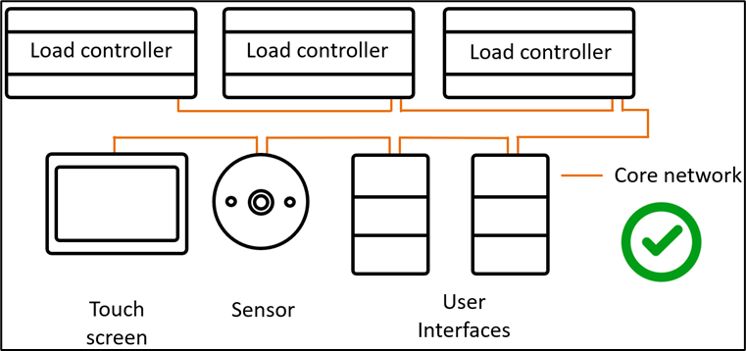
Example of an unacceptable architecture that requires multiple network gateways to pass messages between devices.
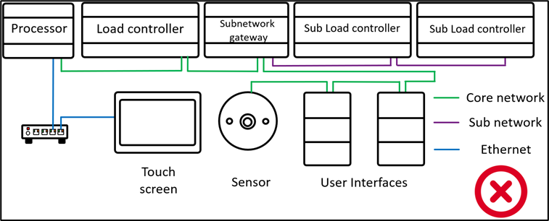

    - All network devices must support configuration, firmware updates, and normal operation via the same network communication port. Systems or devices that separate network communication ports for configuration or firmware update shall not be accepted. This ensures that configuration changes to the control system can be performed quickly and easily via the system commissioning or head-end user software without the need for specialized equipment, additional network cabling, or direct physical access to a specific network device or gateway.
    - All network devices shall be supplied by the same manufacturer, and tested by the manufacturer both individually and together as an interconnected network solution. This ensures that any combination of network devices has proven compatibility and is cross-supported for full system functionality. Network devices that employ different internal strategies to achieve similar functionality shall not be accepted, regardless of whether they share a common communication protocol. This ensures consistent system performance and reduces commissioning complexity. Any system that has reduced functionality due to the combination of devices used, or that requires additional devices to achieve its expected functionality, shall not be accepted.

Example of an acceptable system solution, in which all devices are from the same manufacturer regardless of function or protocol.
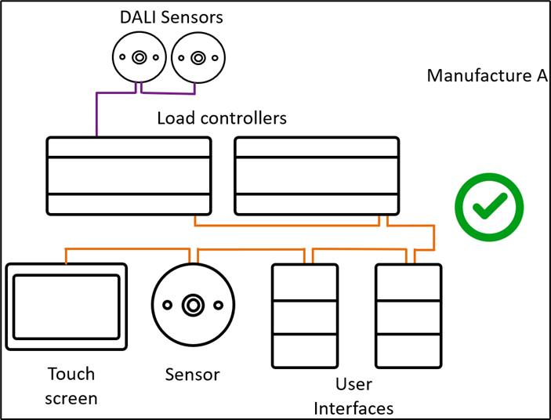
Example of an unacceptable system that depends on the interoperability of devices from multiple third-party manufacturers.
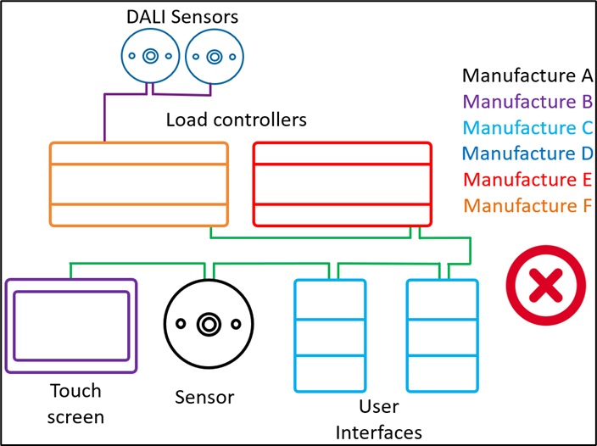

    - The control system shall support all commissioning and configuration via Windows-based commissioning and head-end software. The software must be capable of configuring all network devices, and defining the behavior and relationship between network devices, from any location on the network.

    - Control system performance shall not be affected when the PC (i.e., Windows computer running the NLCS commissioning and/or head-end software) is disconnected. While connected to the NLCS, the PC shall be able to interrogate the system, log all network traffic to file for later analysis, and save system/device configuration information to disk.
    - All load controllers and UIs shall be supplied with a basic configuration so that the control system supports basic default functionality immediately upon installation. UIs should be able to send on, off, and preset scene selection commands to the network, and correctly connected load controllers should respond to these messages appropriately. Achievement of this basic functionality shall not require any commissioning.
    - Each network device shall locally store all configuration data uploaded from the PC within onboard non-volatile EEPROM or flash memory. This data shall remain secure for an indefinite period upon loss of supply. Devices that rely on battery- or supercapacitor-backed RAM shall not be accepted. When supply is restored, the system shall automatically return to its original state at the time of supply loss, without the need for user intervention.
    - Within the system configuration software, UIs and control channel outputs can be arranged and viewed in user-defined logical groups, so that preset scenes and states are easily configured for each group. This provides commissioning engineers with a logical overview of the control system that reflects the actual physical perspective of the end-user. Systems that can only be viewed or configured in reference to physical controllers or devices shall not be accepted.
    - The lighting control system must be run in an on-site enterprise architecture with all required devices for scheduling, day-to-day operations, system monitoring, maintenance, and making configuration changes via the head-end software. Systems that depend on external cloud or server connection for any functionality shall not be accepted. The system must be fully functional without the need for any ongoing connection to external cloud services, whether manufacturer or third-party. This ensures that system integrity can be maintained by the project, independent of any external service that is outside of the project’s control.
    - Any system that depends on a cloud connection for configuration or synchronization, or on the project’s IT infrastructure to be at a required state before the lighting control system configuration can begin, shall not be accepted.

  - Network Physical Layer
    - The control network shall utilize an industry standard RS-485 multi-drop control bus. Data connections between devices on the network shall be four-conductor, with two conductors dedicated to distribution of SELV (Safety Extra Low Voltage) DC supply only, to power button panel UIs and sensors. Each load controller shall contain an integral SELV DC power supply. The failure of a single load controller shall not affect the SELV DC supply to other devices, or the performance of the network.
    - Except for industry standard subnetworks, control systems that multiplex data and SELV DC supply on the same conductors shall not be accepted. Devices shall be connected to the control network via pressure pad screw terminals, RJ12 connectors, or RJ45 connectors.

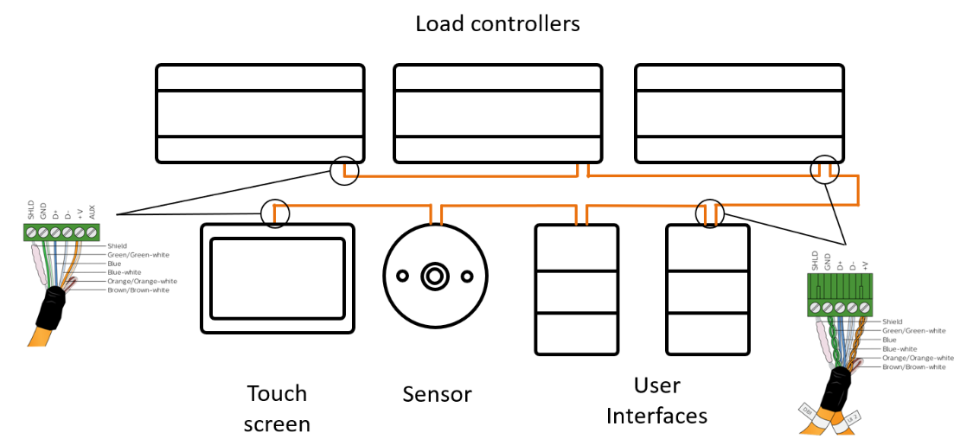

    - Every load controller shall contribute power to the network. Control systems that require a mandatory network power supply to sustain communication shall not be accepted. If required by devices that depend on network power, this can be supplemented by an external power supply.
    - Each load controller should supply enough network power to support at least four button panel UIs without the need for an external power supply. Systems that require an additional external power supply to support four or fewer UIs shall not be accepted.
    - System networks that depend on a single device to send a clock or synchronizing signal to other network devices to coordinate network messages shall not be accepted, as this creates an unacceptable single point of failure.
    - All load controllers must internally support their required resources such as mains power supply, microprocessor, memory, network communications, and internal logic, so that devices are independently capable of their full functionality without additional supporting hardware. Load controllers that depend on external hardware such as power supplies or centralized processors to achieve their core functionality shall not be accepted.
    - The system shall support the use of industry standard CAT5 shielded cable to connect all network devices, ensuring flexible and cost-effective cabling solutions where available. Systems that depend on unique, proprietary, or otherwise non-standard cabling shall not be accepted.
    - The system must be scalable to multiple floors/buildings without third-party hardware. Systems that depend on third-party devices or network infrastructure for scalability shall not be accepted.

  - Network Topology and Protocol
    - A single native lighting control network should directly support 120+ network devices without the need for bridges or gateways to manage network traffic or addressing at scale. Systems that depend on network line/zone couplers to meet project scale shall not be accepted due to the risk of single points of failure and unnecessary network complexity.
    - The manufacturer shall offer the hardware required to create individual network spurs that are galvanically isolated from network trunks.
    - Where required by project scale or physical layout, NLCS gateways shall support the interconnection of multiple networks via the system’s native trunk-and-spur topology or via Ethernet communication between individual networks. Gateways must be configurable by the system’s commissioning and/or head-end software.
    - Network gateways shall support message filtering to minimize unnecessary network traffic between the trunk and the spur they are managing.
Example of a larger system using its native protocol to achieve scalability.
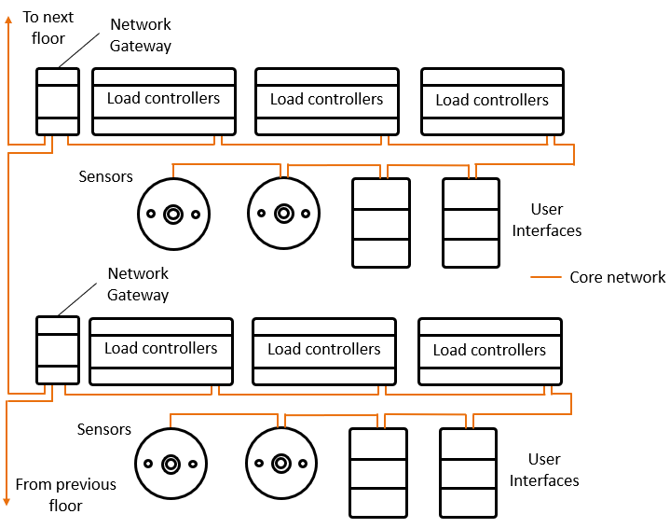
    - The manufacturer shall offer Ethernet gateways that do not require any additional devices to communicate with the system’s native protocol. Ethernet gateways shall support full configuration via the commissioning and/or head-end software to ensure seamless alignment of communication and functionality.

Example of a larger system that achieves scale by connecting multiple networks via the site’s LAN. Each floor network starts from an Ethernet gateway that filters network traffic and can operate independently in the event of a LAN outage.
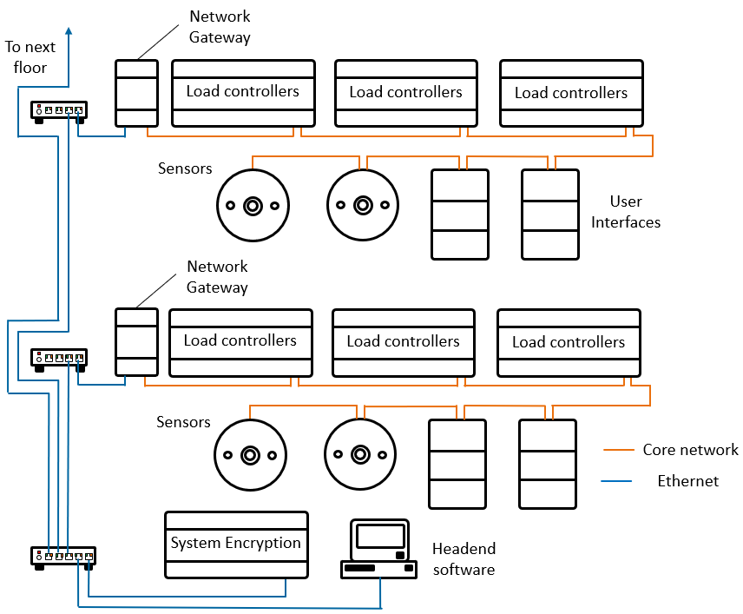
    - When using the site’s own LAN to build scale, NLCS Ethernet devices must use TLS1.2 encryption with mutual authentication between each other to ensure secure operation. Systems that depend on third-party Ethernet devices to pass network messages or provide encryption shall not be accepted. The system must provide its own end-to-end encryption devices on-site.
    - Load controllers that connect directly to the site’s LAN must only communicate to the manufacturer’s own system encryption devices, and should be able to perform gateway functionality to pass on network messages in the system’s native protocol.

  - System Functionality
The Control system shall be capable of deploying all functionalities outlined within this section, with configuration software using a graphical commissioning tool, intuitive mouse-click and drag, drop down dialogue box, or other similar intuitive user programming methods.
    - Occupancy Control

Through sensor-based occupancy detection, enable intensity management of artificial lighting required at any given time, especially in areas that experience high levels of daylight i.e. adjacent to windows.
      - Multistep sensor response: When no movement is detected within a configured timeout period, the NLCS shall be capable of dimming lights to a background level for a grace period to notify users that the lights will soon switch off and then switch all lights off after a further timeout period elapses. The NLCS shall support automatic schedule-based changes to occupancy timeout periods. This enables the use of different timeouts during trading versus after hours.
      - Delay Timers: dimming lights to a background level for a grace time period to notify that the lights will soon switch OFF and then switch all lights OFF after this Grace period expires should no movement be detected in the interim.
      - Daylight Override: When motion is detected in an area with natural light, it shall be possible to configure the control system to only operate luminaires if the light level is below a certain threshold. All NLCS daylight sensors shall be capable of both open loop and closed loop operation, as well as dynamically switching between open or closed loop methods in response to a network message. This enables fine-tuned system behaviors to accommodate varying requirements throughout the day. Daylight sensors that support only open or closed loop operation, or that cannot dynamically switch between these in response to a network message, shall not be accepted. Additionally, all NLCS daylight sensors shall be able to dynamically change their target lux level or step dimming timing in response to a single network message. This ensures that the system can always optimally balance energy savings and occupant comfort, regardless of natural lighting conditions. The NLCS shall support ramping artificial light levels in 1% increments to avoid drawing occupants’ attention while performing daylight harvesting functionality.
      - Step-Over Patterns: In large open offices and public spaces where areas may overlap, the NLCS shall accommodate flexible lighting configurations for adjacent or related areas such as atriums and lobbies. The system shall be able to activate and maintain desired or proportional light levels in multiple areas adjacent to those where occupancy is detected.
      - Multi-zone sensor management: A single occupancy sensor shall be able to trigger multiple lighting zones to illuminate longer corridors and associated areas as needed. This feature must be dynamic, enabling sensors’ occupancy responses to trigger different zones depending on the site’s current schedule status.
      - Open Plan Background Lighting: the system must activate or maintain a background lighting level while at least one work island/station is still occupied. When the last work island area becomes unoccupied, the lights in the open plan must switch Off (with a delay).
      - Corridor Hold-on (Linking): The NLCS shall support linking areas such as function rooms, offices, meeting rooms, and classrooms to associated corridors, waiting/lobby areas, etc., to illuminate a safe exit path. The system must be able to ensure that a corridor is switched on if any one of the areas/offices it services is still occupied. This functionality shall accommodate dimming of exit path illumination if unoccupied while personnel are still present in neighboring areas/offices, for an optimal balance between safety and energy savings.
      - Cascaded Corridor Hold-on: It shall be possible to configure cascading egress path illumination, creating multi-level dependencies whereby rooms keep associated corridors lit, corridors keep elevator/lobbies lit, elevator/lobbies keep reception areas lit, etc. This simplifies commissioning, as well as reconfiguration to accommodate changed site requirements.

    - Light Level Control
      - Switching: The NLCS must support basic switching control to turn lights on and off from a flexible choice of networked user interfaces.
      - Dimming: The NLCS must support dimming control of lighting from a flexible choice of networked user interfaces. This shall be achieved by signal control protocol to a lamp driver (DALI addressable, DALI Broadcast, DSI, 1-10V, or DMX512), or by power control (phase-cut or PWM) dimmers.
      - Scene Setting Task Tuning: To ensure appropriate lighting levels and color temperature for the intended task in a particular area, the NLCS shall provide means for users to readily and intuitively set and adjust light intensity levels and/or preset scenes across any lighting circuit/channels associated with the area/space.
      - Color Component and White Balance Control: The NLCS shall have provision to represent and control luminaires that incorporate multiple channels for color (RGB) or tunable white (warm/cool) adjustment. When integrating white balance control in a DALI network, only one DALI address shall be used for control of both white balance and dimming level. The system must be able to automatically adjust tunable white color temperature in accordance with the time of day, to support natural circadian rhythms (bio-adaptive lighting). Users will have the option to override this behavior as needed – manually selecting a preferred lighting scene via a UI – and similarly to return the lighting to the correct color temperature for that time of day. When bio-adaptive lighting is enabled, the system will respond to occupancy detection by turning on the lighting to the correct color temperature for the time of day. All UIs shall include provision for users to manually ramp the color temperature and/or lighting level of any associated area(s) or channel(s).
      - Corridor-Row Offset: The system shall utilize closed loop light level management to control extra lighting rows offset from the window rows, for at least two extra rows. Zones adjacent to windows receive more daylight than those closer to the core of the building, including corridors in open space. The system must be capable of implementing: Light level control of luminaires in the window areas and the core areas are to be defined by a ratio, dimming window area luminaires to a lower level than corridor or core area luminaires, and luminaires in the area between window and core to a predefined percentage in reference to both.
      - Power Demand Response: The NLCS must be able to receive OpenADR instructions from power supply companies, or from other sources such as solar power systems, to perform load shedding and help prevent overwhelming the power supply which could cause a total failure of the supply system. There should be four levels of load shedding available for the system to step down its current power consumption. Sensors and UIs shall only be able to operate at load shedding level when it is triggered. There shall be no provision to override the load shedding strategy, either by the system or by local users.
      - Load Shedding: Provision shall be available to allow some or all luminaires to dim or switch off when the building’s energy consumption exceeds predefined limits. It shall be possible for the maximum limit to be static or dynamically set, potentially by the energy provider.

    - Personal Control
      - Manual Light Control: The system shall have provision for manual user controls to be implemented where appropriate. Manual controls shall be able to change the behavior of automated functions such as daylight harvesting, occupancy detection, or illumination management.
      - Dedicated User Interfaces: The NLCS shall support manual control via the provision of keypads and/or touchscreens, typically installed at the point of entry into each area or zone as appropriate. UIs must be resilient to cleaning products (antibacterial and sterilizing) commonly used within hospitals so that they do not deteriorate over time. UIs must be available with custom text and icon labeling per button. A simple and easy-to-use customer tool must be available whereby customers can specify labeling requirements. This tool must accommodate both text and icons on the same button. UIs must be available with buttons larger than 1x1 cm (approx. 0.39x0.39 in) for accessibility purposes.
      - Virtual User Interfaces: The system shall offer a range of virtual interface options for manual user control, including but not limited to Android/iOS apps and Windows system tray services.

    - Advanced and Time Control
      - Scheduling: The system shall be able to automatically switch lights on/off, adjust dimming levels, and modify system behavior in accordance with specific schedules. It shall be possible to adjust schedules to accommodate weekends, public holidays, and other shutdown periods. The system shall support automatically adjusting all tunable white lighting to the correct color temperature for the current time of day with a single sitewide network message.
      - Sequences/Tasks/Events: The NLCS shall include a facility to implement conditional and sequential logic control routines. It shall be possible for control routines to be located and run from management software on a PC connected to the NLCS or embedded within individual network devices. It shall be possible to embed tasks as required within sensors, UIs, load controllers, and network gateways. Systems that depend on a centralized processing unit or device to run or enable logic control routines shall not be accepted.
      - Area Linking: The system shall have provision to dynamically link and unlink logical areas where, for example, demountable partitions are used to join/separate physical spaces – typically in meeting rooms, training rooms, conference centers, etc. When partitions are opened, UIs and lighting shall combine to act as a single unified control space. When partitions are closed, UIs and lighting should separate into the discrete areas where they are located. The NLCS must support dynamic linking/unlinking of at least 24 logical areas with configurable unidirectional or bidirectional control. It shall be possible to initiate linking via partition-mounted position-activated reed or microswitches connected to dry contact inputs, or manually via UIs.

  - Product Schedule
    - Product Equipment list is specified in each device type sub-section below.
    - Product quantities shall be shown in schedules, tables, and drawings.
    - All product options are specified in each device type sub-section below.

  - Load Controllers
    - General
      - All load controllers shall be designed to operate continuously at 100% of rated load. They shall be convection-cooled, with no fans or forced ventilation, to reduce noise and increase long-term reliability. Systems that are fan-dependent or fan-assisted, or that recommend regularly scheduled maintenance for air filtration components, shall not be accepted.
      - Load controllers shall be available in wall and DIN rail mounted configurations. Wall-mount controllers shall be directly installable and incorporate a suitable fire-rated enclosure with appropriate protection from access to live parts. DIN rail controllers shall be designed for installation within a switchboard and have a section profile consistent with an IEC style circuit breaker to ensure compatibility with standard load center enclosures. Several types of compatible load controllers shall be natively available, including:
        - Leading and trailing edge power dimming phase control devices for the operation of incandescent lamps, and iron core magnetic and electronic transformers
        - Switching output devices for controlling ON/OFF loads
        - 1-10V, DSI, DALI broadcast, and DALI addressing signal dimming devices for controlling electronically dimmable luminaires
        - Pulse width modulation (PWM) DC devices for controlling LED loads
      - Controllers with fixed outputs shall be completely preassembled and factory-tested by the control system manufacturer. Modular controllers shall have interchangeable control modules, tested by the control system manufacturer, available for assembly by the client’s installer.
      - All DIN rail load controllers within the control system shall follow the same physical layout architecture, including the location and order of the terminals. All devices’ power supply terminations shall be located at the top left side of the device with identical terminal order from left to right: Earth, Neutral, Active supply. Control systems with inconsistent terminal layout or order shall not be accepted. This ensures that installers can quickly terminate the system with minimal risk of error.
      - All output loads must be on the top side of the DIN rail device. All communication terminals (control system protocol, dry contact, DMX512, Ethernet, etc.) shall be located at the bottom of the DIN rail device. This ensures correct physical segregation between SELV and mains voltage cabling.
      - It must be possible to individually configure channels within all load controllers to unique, separately controllable logical areas. Dimming channels must be software-configurable to provide either dimmed or switched output. It must be possible to set minimum and maximum output levels for all channels. Each dimming controller shall support selectable dimming curves.
      - Configuration data relating to individual area names, individual channel names, preset levels, toggle levels, and panic level must be stored within each respective controller’s internal non-volatile memory. Each controller must support device names, area names, and channel names up to 40 characters in length. Each controller must support up to 170 presets. These settings must be downloadable via the manufacturer’s configuration software. Any system that restricts or fails to provide access to these settings shall not be accepted.
      - All load controllers shall incorporate a dry contact AUX input next to the network terminals that enables a BMS to directly trigger a required emergency and/or UL924 response without relying on the NLCS's own network. Load controllers that cannot directly receive dry contact emergency inputs, or that depend on additional intermediate devices to do so, shall not be accepted. The AUX input shall be capable of performing the following minimum functions:
        - Keypad Disabled / Panic / Program Disable
        - Sign-on message
        - Execute logic macro
        - Defined network message transmission
        - Emergency input response and/or UL924 trigger
      - Load controllers shall be available with various individual channel output capacities ranging from 1A to 20A. Up to 12 channels shall be available in a single device.
      - Each load controller shall have a configurable startup delay after power is restored before the controller sends out its sign-on message and begins to initialize outputs. This setting enables staggered startup of multiple load controllers to prevent spikes in network traffic when the system is first energized, and allows time for other peripherals to configure the load controllers before they revert to their previous state.
      - Load controllers with dual serial control ports shall be available for the duplication of control network cabling and to provide redundancy against the failure of one data cable. These load controllers shall be configurable to:
        - Obey control signals from either port
        - Obey the main port if a DMX512 signal is detected
        - Obey the secondary port if signal is lost on main port
        - Obey the highest level received from either port.
      - At startup after loss of power, it shall be possible to configure load controllers to automatically default to one of the following output conditions:
        - All circuits full on
        - All circuits off
        - All circuits to previous condition prior to power loss
        - All circuits to a specific preset scene
      - Load controllers shall respond to a global emergency network message. Once in emergency mode, load controllers shall turn all circuits to 100% until they receive a message cancelling the emergency state. Disabled devices shall not be able to send network messages while in emergency mode.
      - Load controllers shall be able to monitor the network for loss of communications by listening for a network watchdog message. When a load controller does not receive a network watchdog message for a user-defined timeout period (indicating loss of communications), the controller must revert to one of the following load conditions:
        - All circuits to 100%
        - All circuits off
        - All circuits to previous condition prior to communication loss
        - All circuits to a specific preset scene
      - Load controllers shall incorporate a service diagnostic indicator LED. The LED shall operate in the following modes:
        - Normal Operation – The service LED shall blink briefly (approximately 1 Hz) when the dimmer is operating correctly on a quiet network or with no data cable connected.
        - Network Activity Detected - When network activity is detected, the service LED shall blink at approximately 2 Hz for a few seconds, then revert to normal speed.
        - DMX512 Network Activity Detected - When DMX512 is detected, the service LED shall blink continuously at 2 Hz.
      - Load controllers shall incorporate a service switch. When the service switch is pressed momentarily, the controller shall transmit a sign-on message onto the network. If the transmission is successful, the service LED shall indicate network activity detected. The sign-on message shall contain information about the device such as box number, device type, and embedded firmware version. If the service switch is pressed and held for four seconds, the device shall reboot. If the service switch is pressed three times in quick succession, the controller shall drive all outputs to 100%.
      - It shall be possible to upgrade the firmware of all load controllers from any network access point across the control system network. Controllers that require separate communication ports to receive firmware updates or configuration changes shall not be accepted.
      - Load controllers should not have separate network communication ports for service or future development, as these introduce potential security vulnerabilities.
      - Any devices using Ethernet IP communication must use TLS1.2 encryption to prevent security vulnerabilities within the system that may compromise the entire site.
      - All controllers shall be field-serviceable. Permanently sealed devices that require replacement as the only service option shall not be accepted.

    - Switching controllers
      - Switching controllers shall be used for lighting circuits and general electrical loads where automated on/off operation is required. Controllers shall incorporate relays with appropriately rated capacity for typical lighting loads.
      - Relay contact ratings shall be 2-20A continuous AC3.
      - The lighting control system range should include a native relay controller that supports SPDT (single pole double throw) relays to drive bidirectional motors.
      - The relay load controller must utilize two SPDT relays (the first for power, feeding into the second for direction) to drive a single bidirectional motor device so that the NLCS can control the direction and stop the motors at any position. This prevents driving a motorized device in two directions at the same time, which could damage or destroy the device. Devices that depend on software interlocking to prevent driving motorized devices in two directions at the same time shall not be accepted.
      - The NLCS configuration software shall enable linking of two SPDT relay channels to control bidirectional blinds. The controller firmware shall operate the two SPDT relays to ensure that the power relay is open before changing the directional relay. This is required to prevent exposing relays to excessive power rush, which can cause them to weld closed.

    - Signal Dimming Controllers
      - Broadcast Signal Dimming Controllers:
        - The NLCS shall employ signal dimming to control luminaires with integral dimming control gear. Signal dimming controller outputs shall be configurable to 1-10V or DALI Broadcast via the commissioning software.
      - DALI Addressing Controllers:
        - DALI controllers shall be DALI-2 certified with the DiiA (Digital Illumination Interface Alliance), independently from the manufacturer, and listed with supported features on the DiiA website.
        - Each DALI line shall control a maximum of 64 individually addressable luminaires. It should be possible under normal circumstances to connect at least 255 DALI lines to the control network, providing individual control of up to 16,320 LED drivers. It should also be possible to upgrade to a method whereby 65,000 DALI lines can be connected to a single control network, providing individual control of up to 4,160,000 LED drivers.
        - DALI line controllers shall incorporate all required circuitry to connect directly to each DALI line without the use of third-party products. They shall be self-contained and support:
          - Controller unit power supply
          - DALI network power supply
          - DALI network interface
          - Preset scene control
          - Direct connection to the NLCS
        - Control systems that require controllers with external or separate power supplies, DALI transmitters, DALI network interfaces, scene controllers, or any other devices to integrate with the control system network shall not be accepted. Furthermore, systems that require multiple interface connections through assembly of individual components for DALI line adaptation shall not be accepted.
        - DALI lighting system components shall be connected as a set of individual loops, each initially comprising 50 DALI devices per loop. Each loop shall be expandable to incorporate up to 64 DALI devices if required. Loop wiring shall comprise three power (Active, Neutral, Earth) and two data/control cables following the same route. An unswitched active may be incorporated in cable runs to support DALI emergency fixtures. Cables shall comply with the circuiting requirements of this specification. DALI loops may be connected in any combination of radial, star, or bus topology. Ring topologies are not acceptable.
        - DALI loops shall be installed in a logical manner. The addressing sequence for individual DALI devices within a DALI loop shall conform to the IEC standard address randomization process. In applications where DALI device short addresses are preassigned, the NLCS shall be able to preserve short address assignments when enumerating the line. The NLCS shall be able to utilize the 16 native scene groups defined by DALI system specification 62386-101.
        - Individual DALI lines shall be controlled together via the DALI line controllers. The NLCS shall be able to manage multiple DALI lines connected to separate controllers together as one system. Any network UI shall be able to control multiple DALI lines with a single network message. The NLCS must be able to manage logical control areas or lighting groups that span multiple DALI lines across multiple controllers. This ensures that physical lighting looms are unconstrained by the project layout, and that logical areas and lighting groups can be updated without modifying cabling. Any system that requires physical DALI loops to be wired in accordance with logical areas/groups shall not be accepted.
        - The DALI interface should be able to automatically communicate with individual DALI drivers (short address mode) or with DALI group addresses (group and scene mapping mode). This overcomes the native DALI limitations of 16 group addresses and the slow speed of the DALI protocol, and enables the control system to avoid the ‘Mexican wave’ effect caused by unsynchronized dimming of LED drivers. Controllers shall be able to interrogate DALI luminaires to provide the following diagnostic information:
          - Lamp failure
          - Driver failure
          - Driver run time tracking for each driver and lamp output
          - Device Online/Offline status
        - Each DALI line controller must include a user service switch that manually sets the line controller to DALI broadcast test mode, enabling installers to test and verify DALI network wiring by slowly flashing all correctly terminated DALI luminaires.
        - Commissioning of DALI luminaires shall be undertaken by the control system supplier. The control system must support both off-site and on-site commissioning. Systems that require off-site enumeration of DALI drivers shall not be accepted. Single-line DALI controllers shall automatically enumerate DALI drivers when powered on. This automatic enumeration shall constantly run during normal operation to allow one-for-one DALI driver replacement without the need for recommissioning.
        - The NLCS must be able to directly support DALI driver replacement via auto-enumeration or head-end software. This method must be intuitive and straightforward, not requiring expert knowledge of the control system or of DALI addressing architecture. This functionality enables end-users to independently manage their own routine lighting maintenance.
        - DALI line controllers shall continually seek driver address details from their managed DALI line(s). Each controller shall upload all required driver addressing data to the commissioning software when instructed.
        - If a single DALI driver is replaced, the NLCS must support automatic recovery whereby the system automatically detects the change and makes all required adjustments within the system to accommodate the new driver. There should be no need to manually update the control system to support the new driver.
        - DALI line controllers shall support both normal and emergency (DALI 202) fixtures. Control systems that require separate DALI controllers for normal and emergency DALI luminaires shall not be accepted. The control system shall be able to test the lamp status and battery condition of connected DALI emergency luminaire, and to report the outcome of both functional and duration tests.
        - DALI line controllers shall support tunable white (DALI 209) drivers. Systems that can only achieve tunable white functionality with separate warm/cool white luminaires shall not be accepted.
      - DALI Single-Master Controllers
        - Where practicable, DALI single-master controllers shall be used to reduce wiring complexity by supporting native DALI input devices (sensors, keypads, and dry contact interfaces) on the DALI line loop. DALI input devices must be fully powered from the DALI bus. DALI input devices that require an additional power supply shall not be accepted.
        - DALI input devices shall be completely configurable from the NLCS commissioning software. Any DALI input device that requires direct or manual adjustment shall not be accepted.
        - DALI line controllers shall be able to translate and relay messages from DALI input devices to the rest of the control system network in its native protocol, so that DALI input devices can control lighting beyond their local DALI line.
        - DALI single-master controllers shall support up to 10 DALI input devices on a 64-driver DALI line, and up to 16 DALI input devices on a 34-driver DALI line.
        - It shall be possible to upgrade the firmware of DALI input devices via the DALI bus.
        - DALI single-master controllers shall have provision to dynamically adjust luminaire fade rates, open/closed loop sensor functionality, number of addressable areas affected, or timeouts as configured in either the DALI UIs, other devices on the control system network, scheduled events, or head-end software instructions. This enables fine-tuning of the system to balance the needs of site occupants and system owners.
      - DIN Rail Mount DALI Line Controllers
        - DALI line controllers shall be offered in DIN rail mount configuration, in single- and triple-line configurations to control up to 64 or 192 DALI addresses respectively. DALI line controllers shall be powered directly from mains supply without the need for an external low voltage power supply.
        - DIN rail mount DALI line controllers shall incorporate optional standby power management via an integral 20A switched output per line, with an appropriately rated relay for typical lighting loads. for control of the mains power circuit that feeds each line’s connected luminaires. This output will automatically disconnect the mains power supply to the luminaires when all luminaires on the associated DALI line are dimmed to 0% output (off state), removing all standby current consumption from the DALI luminaires. This function should be completely automated by the lighting control system and require no additional commissioning. Control systems that do not accommodate integrated power supply management to DALI drivers, or that depend on external devices to perform this function, shall not be accepted.
      - DALI Commissioning
        - The NLCS commissioning software shall support full commissioning and enumeration of DALI controllers, drivers, and input devices, with graphical representation of all DALI luminaires and control system products.
        - The system’s DALI controllers must automatically start scanning their associated DALI networks for all available drivers and input devices when first powered up. This speeds up the commissioning process so that all required DALI device addressing information is available and ready within the DALI controller. Systems that require manual input to trigger this function shall not be accepted.
        - DALI controllers must support setting and reconfiguring DALI addresses, group addresses, and scene level settings from within the commissioning software. Systems that require third-party commissioning software to set any of the above shall not be accepted.
        - Initial programming shall be via graphical icon positioning and grouping, writing data to products and a single database simultaneously. Systems that require pre-configuration of DALI drivers shall not be accepted.

    - DIN Rail Multipurpose Controllers
      - DIN rail multipurpose controllers shall be used in applications that require operation of various small load types in a specific location such as a waiting area, meeting room, cafeteria, etc.
      - Controllers shall have 8 output channels and be housed in a 12-unit width DIN rail mount enclosure. Controllers shall support a maximum load of 16A.
      - There shall be a range of plug-in output modules available to suit various load types including:
        - Signal dimming with two channels, software-configurable to DALI Broadcast,
        - 1-10V, and DSI
        - Leading edge (forward phase) power dimming
        - Trailing edge (reverse phase) power dimming
        - Switching control
        - Motorized blind/curtain control
        - Fan control
      - The controller should optionally incorporate front panel channel status indicators with a manual override toggle switch for each output.

    - Wall-mounted Multipurpose Controllers
      - Wall-mounted Multipurpose Controllers shall be used in applications where operation of various larger load types is required in a single location.
      - Different sized enclosures shall be available for a different number of multichannel output modules (2, 4 or 6 module bays). There shall be a range of plug-in output modules available to suit various load types including:
        - Phase-cut dimmer module
        - Signal dimmer module
        - Relay module
      - Standard modules shall be provided for all controllers:
        - Supply module
        - Communications module
      - The controller shall be encased in a galvanized steel enclosure, suitable for surface and recess mounting. The enclosure shall be safely mountable before modules are installed. The enclosure shall include multiple knockouts to cater for flexible wiring configuration. The enclosure shall include two separate front covers so that high and low voltage sections can be accessed separately. Circuit breakers shall protrude through the front cover for visibility and ease of access.
      - The enclosure module bays shall include mechanical interlocks to ensure correct module location. A wiring loom shall be supplied with the enclosure, fitted with plastic collars to ensure proper wiring orientation and prevent installation errors.
      - All supply and communications terminals, as well as circuit protection, shall be fitted to each module. Output modules shall plug in to any available output module bay and shall not require modification for installation. All modules shall be fully encased in a metal enclosure.
      - The controller shall have interchangeable communication modules to accommodate different protocols. The supply, communications and output modules shall be individually replaceable. During servicing, replacement output modules shall be automatically rediscovered and reconfigured without commissioning software.
      - The phase cut output modules shall be capable of Leading/Trailing Edge dimming. The module shall attempt to identify the required dimming type using harmonic analysis, and allow manual selection of dimming type via the commissioning software.
      - The signal dimmer output module shall be software-selectable for 1-10V, DSI, DALI Broadcast, DALI Addressable and DALI MultiMaster.
      - The communications module shall have a dry contact input, an indicating LED for device and network status, an override keypad to allow testing of all modules and channels, and a service switch to enable network sign-on and device reset without opening the enclosure.

    - J-box mounted controllers
      - The load controller must support a 20A relay switching capability along with dimming functionality.
      - The load controller must be capable of being installed and mounted on a standard junction box.
      - The load controller must support standalone mode for room-based applications without requiring any software-based configuration tool or networked mode for integration across multiple spaces.
      - It must be possible to toggle the zone assignment of the controller with physical button-press action on the controller and without requiring any software-based configuration tool.
      - It must be possible to logically pair the controller with compatible sensor and user interfaces without requiring any software-based configuration tool.
      - It must be possible to toggle the dimming output of the controller between 0-10V and DALI broadcast signals.
      - The controller must support current sink and sourcing capacity of 100 mA
      - The controller must support 1 x DMX 512 input addressing
      - The controller shall provide:
        - Service Switch
        - Diagnostic LED
        - (1) Class 2 dry contact inputs, consisting of 1x14 AWG screw terminal.
        - (1) DMX 512 addressing input
        - RS-485 Serial Port connections provided by six (6) 1x14 AWG screw terminals.
      - The controller must support diagnostic functions, including:
        - Device Online/Off-line status via a LED status indicator.
        - Diagnostic Functions, indicating device Online/Offline status, shall also be accessible through supporting software, Touch Screen, and BAS interface.

    - Pre-assembled control cabinets
      - The controls cabinets must be pre-assembled and tested in a USA located factory in a NEMA 1 rated enclosure.
      - The control cabinets shall support up to 24 control outputs per cabinet, individually configurable to 0-10V or DALI broadcast.
      - The control cabinets must be offered in a configuration that supports up to 3 DALI lines per cabinet with full support for addressing, tunable white, and RGBWAF*, as well as an inbuilt DALI power supply and driver power management.
      - The control cabinets must be offered in a configuration that supports up to 16 forward- or reverse phase channels per cabinet.
      - The control cabinets must provide flexibility to populate up to 8 module bays per cabinet with any combination of forward/reverse phase dimming, 1-10 V, DALI broadcast, relay switching, and motorized curtain/blind control.
      - The control cabinets must support a configuration that enables LAN connectivity for commissioning and system management, an integrated web server for browser-based control and monitoring, and a huge range of enhanced functionality and integration options.
      - The control cabinets must support a configuration that provides optically isolated network spurs and enables a range of third-party integration options including AV systems, building automation, and DMX512 lighting.

  - User Interfaces
    - General
      - A range of compatible user interfaces shall be available for direct connection to the control network, including:
        - Keypads with physical/mechanical or capacitive-touch buttons
        - Keypads with LCD display for menu navigation and option selection
        - Color touchscreens
        - Virtual interfaces (browser- or app-based)
      - Keypads shall be sized to suit locally available wall boxes.
      - Mechanical keypad button caps must readily interchangeable and accommodate standard or custom labeling/engraving.
      - All networked keypads connected directly to the NLCS shall communicate using the system’s native protocol.
      - All keypads shall be configurable so that any button input can initiate, at minimum, one of the following events:
        - Select a preset
        - Set a channel to a specified level
        - Start/stop a task
        - Link/unlink areas
        - Send any valid user-defined network message, or sequence of messages
      - Keypads must contain an internal processor that can perform conditional and sequential logic functions. Systems that rely on external or centralized logic processors shall not be accepted.
      - Keypads shall provide an immediate local status LED response upon button activation, or upon detecting a network message with the same command function to indicate the corresponding change in system state. Keypad status LEDs shall also be individually controllable via the network.
      - All keypads shall be completely configurable via the commissioning software, from anywhere on the control system network, without additional drivers or plugins. Control system keypads that require direct connection or additional commissioning software drivers or plugins shall not be accepted.
      - It shall be possible to upgrade the firmware of all keypads over the control network.
      - Keypads shall incorporate a sign-on function that, when activated manually, transmits a sign-on message to the network. The sign-on function can be triggered by pressing any two of the standard UI buttons at the same time. There should be no need to remove the UI from its mounting location to gain access to the sign-on trigger. The sign-on message shall contain information about the device such as network address/ID, device type, and embedded software version to identify the device on the network for faster configuration. Systems that do not support network identification of UIs from each device shall not be accepted.
      - Keypads must include proximity detection that wakes them from an ultra-low power standby mode when a user approaches. When in standby mode, all indicators should be completely off and only reveal themselves when the proximity sensor is triggered.
      - Keypads must also include an ambient temperature sensor. When requested by the NLCS, the keypad can communicate the local current temperature to the network. Internal logic within the sensor should be able to trigger a network message when a particular temperature is detected. The temperature range shall be 5-40°C (41-104°F) with +/- 1.5°C (2.7°F) accuracy. The NLCS must be able to dynamically change the system’s reference temperature sensor and/or calculate the average reported temperature from multiple UIs.
      - Each keypad shall include an interchangeable communication module that is compatible with the manufacturer’s full range of keypads. This communication module contains all configuration information needed for the keypad’s functionality. The communication module shall be configurable without the application module attached.
      - It shall be possible to upload 16 different configurations to the keypad, each of which can be selected during installation using an accessible DIP switch. This enables fast deployment of keypads on-site for different applications.
      - The manufacturer shall offer keypads with IP22 and IP40 ratings for more flexible installation options.
      - Keypads shall be constructed of materials that will not fatigue when cleaned with hospital-grade disinfectants, bleaches, or antibacterial cleaners.
      - Keypads must not have sharp edges or corners.
      - Keypad construction must ensure smooth button operation, even when mounted on an uneven wall surface or with excessive torque applied to the mounting screws during installation.
      - Each button can be labeled with text or icons to indicate functionality. This should be easily configured using an online tool that does not require in-depth knowledge of the system or its part codes. This enables end-users to directly configure their desired finishes and labeling options.
      - Keypad button configuration shall allow templated programming for the following functions:
        - Preset selection
        - Ramping of lighting level
        - Ramping of color temperature
        - Room join/unjoin
        - Toggle preset
        - All lighting on/off

    - Antumbra keypads
      - Keypads shall be available with 6, 4, or 2 buttons, with the option to mechanically disable individual buttons if needed.

    - Antumbra Display
      - A keypad shall be offered that incorporates a built-in LCD display to show system information, menu navigation, and button labels/icons.
      - The display should be capable of showing the following system information:
        - Current scene selected (via dynamic icon or text)
        - Current time
        - Current measured temperature
        - Current temperature setpoint
        - HVAC mode and fan speed
        - Lighting or volume channel level (bar graph or % indicator)
      - Keypads with built-in LCDs shall be able to display dynamic information in a range of languages and icons. The display keypad shall support different modes of operation for trading and after hours functionality.

    - Antumbra Touch
      - Keypads shall be offered that utilize capacitive touch technology with no moving parts. These keypads shall provide audible feedback to acknowledge a button press.

    - Revolution
      - Keypads shall be offered that provide RGB backlighting to illuminate button text/icon engraving. The keypad’s backlight brightness, as well as each individual button’s backlight color(s), shall be configurable via the commissioning software.
      - These keypads shall be available with 8, 4, or 2 buttons to meet different project needs.

    - DirectSet
      - Keypads shall be offered that fit standard North American wall switch format and ensures seamless integration with industry standard electrical boxes and wallplates.
      - Keypad shall support built-in dual RJ45 ports for hassle-free wiring termination.
      - Keypad must include two rotary switches for selecting keypad style (button configurations) and zone assignment.
      - Keypad must be offered with preloaded multiple button configurations, selectable via easily accessible rotary switches.
      - The keypad must support standalone mode for room-based applications without requiring any software-based configuration tool or networked mode for integration across multiple spaces.
      - The keypads must support networking functionality with the NLCS and shall communicate using the system’s native protocol.
      - Keypads must support built-in LED indicators for each button configuration that illuminates respective buttons when selected or pressed.

    - Touchscreens
      - Configurable color LCD touchscreens shall be used in locations with complex UI requirements that are likely to change over time, and where it is advantageous to provide access to some system maintenance functionality. Touchscreens shall support a minimum of 255 user-configurable pages.
      - Touchscreens shall incorporate a capacitive touch interface for all user interaction. Touchscreens that include physical buttons or other moving parts required for any user interaction shall not be accepted.
      - Touchscreens shall connect directly to the NLCS and communicate in its native protocol. Authorized users shall be able to initiate any of the following events by pressing a graphical onscreen button:
        - Navigate to another page
        - Select a preset scene
        - Set a channel to a level
        - Start/stop a task
        - Link/unlink areas
        - Send any valid user-defined network message or sequence of messages
      - Touchscreens shall incorporate an internal task engine to perform conditional and sequential logic functions. Systems that rely on an external or centralized logic processor shall not be accepted. All setup and configuration information must be stored on the touchscreen in non-volatile memory, including user-uploadable UI pages and custom graphics.
      - The touchscreen shall include user PIN code protection to manage authorized access to settings and restricted pages.
      - The touchscreen must be developed by the same manufacturer as the lighting control system and communicate directly with the control network via its core protocol to ensure full interoperability with the rest of the system. Any touchscreen that depends on network gateways, Ethernet connectivity, or external processors to support functionality or connectivity shall not be accepted.
      - The touchscreen must be fully configurable from the NLCS commissioning software. The manufacturer must also provide a user-friendly application to easily create and customize touchscreen UI pages based on project data exported from the commissioning software.
      - Touchscreens that depend on removable storage media for configuration or firmware shall not be accepted, as this introduces security vulnerabilities.
      - The touchscreen shall include built-in temperature and humidity sensors.
      - The touchscreen shall include a real-time clock and scheduling functionality and support basic schedule editing through the touchscreen itself without the need for commissioning or head-end software.

    - Virtual Interfaces
      - In areas that require sophisticated and integrated control of lighting, blinds/curtains, HVAC and potentially AV equipment, i.e. boardrooms, lectures theaters, and meeting rooms, Wi-Fi connected portable touchscreen computing devices shall be used. The interfaces shall provide intuitive screen layouts that simplify operation of the systems in their associated spaces. The devices shall be cost-effective consumer type using free downloadable applications authored by the control system vendor. Systems that use third-party applications will not be accepted.
      - Applications shall be available that utilize standard templates which are auto populated from commissioning software configuration data. Applications of this type shall be available for devices that use the Apple iOS and Google Android operating systems.
      - Alternate applications shall also be available that permit full customization of the users screens. This type of application shall be available for devices that use the Apple iOS operating system.
      - Browser based access to control system functions will optionally be provided by the control system vendor.

  - Sensors
    - Networked multifunction sensors shall be installed in appropriate locations to minimize energy consumption through daylight harvesting and occupancy detection control. All sensors shall include a photoelectric (PE) sensor, passive infrared (PIR) motion sensor, and an infrared (IR) receiver, and must be able to support all three detection elements at the same time.
    - The NLCS manufacturer shall offer sensors that also include ultrasonic (US) occupancy detection in addition to the above. These sensors shall be dynamically configurable to utilize PIR, US, or both, in accordance with system schedules or current occupancy state.
    - Systems that depend on separate motion and light level sensors shall not be accepted. Only networked multifunction devices with both motion and light level sensors are to be used. Sensors must simultaneously perform both motion and light level detection.
    - All sensors must be true network devices with no additional hardware required to perform their core functions or communicate with the NLCS in its native protocol. Sensors must be powered directly from the NLCS. Systems that depend on sensors with separate external power supplies, or sensors that communicate via dry contact interface or any other external integration device, shall not be accepted.
    - The NLCS sensor range must support the following PIR scan pattern angles:
      - 360°
      - 90°
      - 30°
    - All 360° PIR sensors must be available in surface and recessed mounting options.
    - All 90° and 30° PIR sensors must include a flexible ball joint to accommodate orientation adjustment after mounting. Narrow scan pattern sensors with fixed mounting position, or that depend on masking accessories, shall not be accepted.
    - Sensors shall be supplied with all required components to complete their full installation. Sensors that require separately supplied mounting accessories shall not be accepted. This ensures full transparency of sensor costs and installation/maintenance requirements.
    - The NLCS sensor range must include sensors with IR receive support for industry standard RC5 commands to trigger, at minimum, the following:
      - Select preset
      - Ramp lighting up/down
      - Toggle on/off
    - Sensors shall be capable of conventional motion detection with user-definable timeouts. Sensors shall also incorporate an intelligent function that automatically extends the no-motion timeout period if motion is detected immediately after the sensor sets the status to unoccupied.
    - Sensors must support dynamic automated adjustment of operational functionality and responses at varying times throughout the day, in response to a scheduled network message.
    - The manufacturer’s product range must include a sensor that can be mounted bedside to detect when a guest leaves their bed and trigger an appropriate response, such as turning on the room lighting at an appropriate level, turning on bathroom lighting, and/or notifying staff that the occupant has left their bed.
    - Sensors must work in conjunction with any color temperature biorhythm strategies to automatically recall the appropriate lighting color temperature for the time of day.
    - Sensors shall incorporate at least 8 preset control modes for motion detection and 8 preset control modes for illuminance control to provide effective occupancy and daylight harvesting functionality.
    - Sensors shall include a function that enables them to enter a testing witness mode, whereby the timeout delay is shortened in order to quickly verify effective occupancy control during commissioning. It shall be possible to enable and disable witness mode across a complete site or section thereof from within the commissioning software, without the need to modify or enter new configuration data individually for each sensor. Systems that require configuration data to be modified on a sensor-by-sensor basis to implement a witness mode shall not be accepted.
    - All occupancy sensors shall support photoelectric (PE) light level monitoring independent of occupancy detection. PE trending data shall be available via the control system software, where sensitivity can also be calibrated.
    - PE sensors must be capable of operating in a closed loop function whereby they directly measure combined local light levels from natural daylight and artificial lighting. Additionally, sensors should support open loop daylight regulation whereby they directly measure only the natural daylight. If required, a single PE sensor in open loop configuration should be able to adjust every lighting group on the entire network.
    - PE sensors should be able to ramp lighting levels in small enough incremental steps to ensure that occupants are not aware of or distracted by the changes.
    - Sensors shall be easily configurable to achieve daylight-dependent (harvesting) illuminance regulation. The sensor should be capable of providing PID (proportional-integral-derivative) illuminance control for applications where continuous regulation is preferred. It shall be possible to dynamically enable and disable this functionality by sending a network message.
    - During the commissioning process the sensor can be set to stream current PE levels back to the commissioning software. This information shall be presented in a graphical format so the commissioning engineer can assess conditions and set appropriate thresholds to trigger actions in the control system.
    - For rapid deployment of basic illuminance control, sensors shall incorporate auto-calibration functionality. It shall be possible to initiate auto-calibration across a complete site or section thereof from within the commissioning software via a few simple mouse clicks, without the need to modify or enter new configuration data individually for each sensor. Systems that require configuration data to be modified on a sensor-by-sensor basis to implement auto-calibration shall not be accepted.
    - All sensor configuration and firmware updates shall be made from commissioning software via the control network. Sensors that require manual adjustment methods such as potentiometers or DIP switches to set illuminance thresholds shall not be accepted. All configuration data required for normal operation including area, illuminance thresholds, motion detect actions, etc. should reside in the sensor’s non-volatile memory.

  - Networking and Integration
    - RS-485 Gateways
      - RS-485 network gateways shall be used in strategic locations on the LAN as necessary to establish a trunk-and-spur topology for efficient data transport. Network bridges shall be installed where required to facilitate serial communication with third-party systems.
      - The RS-485 gateway shall contain two RS-485 data ports, galvanically isolated from each other. The gateway shall support bidirectional variable message filtering to block or forward messages based on:
        - Area
        - Message type
      - The RS-485 gateway shall incorporate an internal task engine to perform conditional and sequential logic functions. Control systems that rely on an external or centralized logic processors shall not be accepted.
      - It shall be possible to configure the RS-485 gateway for DMX Tx/Rx operation:
        - One RS-485 port as DMX512 Tx, capable of transmitting 512 channels of DMX512 levels
        - One RS-485 port as DMX512 Rx, capable of receiving 512 channels of DMX512 and converting them to channel level messages

    - RS-232 Gateways
      - RS-232 network gateways shall be available for serial port integration between the NLCS and third-party devices/systems such as AV, lighting desks, data projectors, HVAC, BMS, and security. RS-232 network gateways shall be powered from an external DC supply or the control network.
      - The RS-232 network gateway shall incorporate an internal task engine to perform conditional and sequential logic functions. A library of data formats shall be available for systems integrators, or can be created using the onboard conditional logic engine to assemble and transmit user-defined data strings.

    - Ethernet Gateways
      - Ethernet network gateways shall be available to establish trunk-and-spur topology with an Ethernet trunk, provide remote control of sites, collect system operation data, and interface to a range of IP-based protocols and third-party systems.
      - Ethernet network gateways shall support TCP/UDP, IPv4/IPv6, unicast/multicast/broadcast, DyNet1, DyNet2, Fidelio, BACnet*, and ‘Text and Binary Integration’ protocols.
      - Ethernet network gateways shall support IPv4 and IPv6 with static or DHCP addressing and configurable routing.
      - Ethernet network gateways shall provide secure cloud connectivity to the building with user configurable routing and a choice of RS-485 and Ethernet bridging functions.
      - Ethernet network gateways shall include online/offline status reporting for connected devices, network traffic logging, secure remote firmware update and lighting control metrics. Inbuilt timeclock and schedule manager allow the user to manage automated operations and task scheduling.
      - Ethernet network gateways shall enable users or third-party systems to run macros such as ‘After Hours’, ‘Shut Down’, ‘Welcome’ and more.
      - Ethernet network gateways shall include an integral web server for browser access, real-time clock with action scheduler, and an internal task engine to perform conditional and sequential logic functions. Systems that rely on external or centralized logic processors shall not be accepted.
      - Each ethernet network gateway shall support TLS1.2 encrypted communication with up to 25 Ethernet-equipped controllers.
      - The ethernet network gateways must be BACnet certified by external 3rd party BACnet testing auditors.

    - Remote TCP/IP Access Interface
      - An Ethernet network gateway shall be available that includes a remote access interface, enabling end-users and authorized support personnel to securely tunnel into the NLCS via a remote TCP/IP connection.
      - It shall be possible to perform all control, configuration, and commissioning functions across this interface that can be performed via a direct connection to the NLCS. The interface shall also incorporate an embedded web server that enables system control pages to be authored and stored on the device and viewed on a standard web browser from any connected computer or smart device.

    - HVAC Valve Controllers
      - The control system device range must include a dedicated fan coil unit controller (FCUC) designed for direct connection to components commonly found in heating, ventilation, and air conditioning (HVAC) plants with fan coil units (FCU).
      - The FCUC must support automated hysteresis to correctly respond to temperature changes and prevent the system from oscillating out of control.
      - The FCUC must be universal, with outputs to support 0-24V TRIAC valve control or 0-10V valve and fan control, as well as relay switching for control of FCU fans and auxiliary heaters.
      - The FCUC must support 4-pipe, 3-pipe, or 2-pipe systems.
      - Fan speed control must support switched control via three relay outputs for 3-speed fans, or silent 0-10V control for compatible variable-speed fans.
      - The FCUC must include a general-purpose relay (GPR) output to support floor heating or other related temperature management functions.
      - The NLCS commissioning software must include a configuration wizard to automate the FCUC commissioning and response calibration process.
      - The FCUC must support multiple modes so that its functionality is dynamically adjustable in response to the area’s current or intended occupancy.
      - The NLCS must support valve control curve configuration to ensure optimal valve drive operation. The valve control curve can be configured with the following features:
      - Linear dependency of valve position vs. valve control value in the active valve opening range, as per the valve specifications.
      - Restriction of valve minimum and maximum position. Some valves may have almost no flow when slightly open, reach maximum flow rate at 60-80% open, and/or generate disruptive ‘whistling’ sounds at low flow rates. These issues can be reduced or eliminated by limiting the active valve opening range.
      - Configuring the valve minimum control effort (%) required to make the valve move, reducing unnecessarily frequent positioning.
      - Restricting valve control values to a range within the valve’s specified minimum/maximum level (%) thresholds. The valve output does not react to values outside of this range, eliminating unnecessary movement when there is negligible demand for heating or cooling.
      - The FCUC must include four configurable control inputs to interface with dry contact outputs, 0-10V outputs, and a 20 kΩ NTC temperature sensor.
      - The FCUC shall integrate local HVAC control with the NLCS native protocol, enabling HVAC control from anywhere on the control system network.

    - Dry Contact Input Interface
      - Dry contact input interfaces shall be used where required to integrate control from other systems and devices via switch or relay closure. Dry contact input interfaces shall be galvanically isolated for immunity to noise and to protect internal electronics. It shall be possible to connect the dry contact interface to switches located up to 20 meters from the interface. The dry contact interface shall have an isolated internal power supply, powered from the control system network, to provide a reference voltage for inputs.
      - The device should optionally support receiving analog inputs of 0-10 VDC or 0-5 VDC.
      - The device shall incorporate an internal task engine to perform conditional and sequential logic functions. Control systems that rely on an external or centralized logic processor shall not be accepted.
      - The dry contact interface shall be able to initiate any of the following events:
        - Select a preset scene
        - Set a channel to a level
        - Start/stop a task
        - Link/unlink areas
        - Send any valid user-defined network message, or sequence of messages

    - Miniature Dry Contact Interface
      - Miniature dry contact interface devices shall be used to connect third-party sensors and custom switches to the NLCS. The interface shall be no larger than 53 x 30 x 15 mm (2.1 x 1.2 x 0.6 in), suitable for mounting within compact wiring enclosures.
      - The interface shall have 8 inputs and 8 outputs for LED indicators, and shall be able to initiate any of the following events on a change of state of the contact:
        - Select a preset scene
        - Set a channel to a level
        - Link / unlink areas
        - Send any valid user-defined network message
        - Emulate the operation of a motion detector
      - Miniature dry contact interfaces shall also be available that connect directly to a DALI bus on a single-master controller. This device must also be software configurable and firmware updatable over the DALI bus from the control network.

    - Integration to third-party systems
      - It shall be possible to easily integrate to third-party systems such as:
        - Audio-visual systems
        - Building management systems
        - HVAC systems
        - PABX systems
        - Access control systems
        - RS232
        - IR
      - Direct network connection to common AV control systems shall be possible, and the manufacturer shall have interface libraries written for the following popular systems:
        - AMX
        - Crestron
      - It shall be possible to integrate to the lighting control network using any of the following methods:
        - From site management software:
          - ActiveX
          - DCOM
          - DDE
        - Using dedicated control network gateway interfaces
          - KNX
          - BACnet
          - LON
          - MODBUS 485
          - Somfy

  - Software
    - Management Software
      - Intuitive head-end site management software shall be provided so that local client personnel can operate & manage the system. The software shall run on Microsoft Windows, incorporating secure multi-level user access control. The software shall incorporate a 2D graphical interface with simple mouse-driven controls, with icons that can be positioned to represent each element in the control system, including individual luminaires. To assist site navigation, the software must be able to import floor plan backgrounds from common drawing file formats including BMP, EMF, GIF, JPEG, PDF, PNG, TIFF, and WMF. The software floor plan display shall include virtual wiring & it shall be possible to add, remove, & modify logical areas using click-and-drag.
      - The head-end software must support direct import of commissioning software files to ensure alignment with system hardware configuration, provide full access to all system functionality, and reduce commissioning times for faster project handover.
      - The head-end software shall enable luminaires to be assigned to a group/area by clicking and dragging them to a floor plan region, and to be controlled individually or by group/area. It shall be possible to double-click anywhere within an area boundary to access a preset editing view for that area.
      - The head-end software should not require extensive training or in-depth knowledge to operate its features and functions.
      - The software shall enable the system to be readily reconfigured using click-and-drag to accommodate changes in physical layouts and logical area groupings.
      - Luminaire icons within the software floor plan display shall change color to reflect the actual status of each lamp. For example, yellow for on, grey for off, and blinking to indicate when a lamp exceeds its allowable run time and should be replaced.
      - From the head-end software the user can make instantaneous lighting level adjustments and preset scene selections. When this is done, new levels can be saved directly to the load controller(s) responsible for managing the affected lighting groups. This is required so that end-users can adjust the system when required without depending on external technical support.
      - The head-end software shall support adjustments to sensor timeouts and target lux levels for a selected area. When such changes to an area are made, the software shall then adjust all required settings in any affected devices.
      - The system shall be able to keep track of luminaire data such as manufacturer, part number, wattage, life expectancy, managing load controller, date installed, & location.
      - The head-end software shall support direct management of all control system devices and reporting of any faults that may arise back to the end-user.
      - It shall be possible to display the full properties of each luminaire within a properties dialog box that is readily accessible from a drop-down menu on the respective luminaire icon. The luminaire properties must include the following information:
        - Area
        - Lamp control group
        - Luminaire location / ID number
        - Lamp make and model
        - Manufacturer estimated lamp life
        - Cumulative true running hours
        - Cumulative weighted running hours (incandescent lamps, corrected for power)
        - Real-time lamp active status
        - Date of last lamp replacement
      - The lighting control system shall incorporate an action scheduler to automate time-based events. It must be possible to trigger scheduled events as a one-off timed event or on a recurring basis. The scheduler shall be able to initiate events or sequences of events at a specific time, either absolute or relative to sunrise/sunset, on a specified:
        - Day of the week
        - Day of the month
        - Calendar date
      - Sunrise and sunset information may be determined by latitude and longitude, and the system shall automatically keep track of daylight saving periods and leap years. It shall be possible to schedule the date of recurring events in several ways:
        - At a specific day and time each week
        - On a specific day of the month
        - On a specific day of the week each month
      - Similarly, the time of recurring events can be scheduled in two ways:
        - Absolute (e.g., 16:00, 05:15, etc.)
        - Relative (e.g., 2 hours before sunset, 15 minutes after sunrise, etc.)
      - For recurring events, the end-user must be able to schedule exceptions.
      - The system management software shall incorporate a macro-based logic control builder that utilizes a plain language function editor. The macro builder must be able to handle sequential control routines. The macro facility must present a range of standard and common control routine templates to assist the implementation of typical control scenarios.
      - The lighting control software must incorporate user/password-based access security with support for alternate menu structures in accordance with each user’s defined permission profile(s). The system must automatically log users out after a defined time-out period since their last keyboard or mouse activity. The system shall record the time that each user logs on/off, and if logging off was manual or automatic, for review by the system administrator.

    - Commissioning Software
      - It shall be possible to completely pre-commission the software off-site without any connection to the lighting control network. Completion of commissioning using the pre-configuration approach, shall then only involve connection of PC with software to the lighting control network, signing on of network devices, and then downloading all configuration data to the devices.
      - Offsite pre-commissioning shall also be possible for systems that incorporate DALI controllers and luminaires. Provision shall also be included to accommodate both enumerated and non-enumerated DALI luminaires.
      - To ensure on-time completion of commissioning, it shall be possible to independently operate and commission sections of a facility, i.e. individual floors of a multi-story building, as discrete networks. The commissioning and management software shall also enable configuration files for each of the respective individual areas to be merged into a master site file as they are completed and connected to the overall site network.
      - The software shall be capable of configuring all parameters of DALI devices connected to the DALI universe controllers including enumeration of short addresses. The lighting control system must be able to configure ballasts without having to use ‘Ballast Suppliers Software’ or hardware creating intermediate third-party data bases. DALI universe controllers and configuration software shall be capable of natively supporting all DALI configuration and control functionality. Systems that require separate third-party software and interfaces to enumerate devices and assign short addresses will not be accepted. The lighting control systems DALI load controller should support all DALI commissioning requirements. Control systems that are dependent on additional third-party hardware for the commissioning process will not be accepted.
      - The commissioning software must be able to configure all elements of the lighting control system. Any commissioning software that requires additional patches, plug-ins or drivers to perform commissioning will not be accepted.
      - The commissioning software will allow multiple programmers on the same network at the same time.
      - The commissioning software will automatically produce a report of all system settings.

    - System Health Monitoring
      - The system shall be able to assign essential and non-essential lighting on a circuit-by-circuit basis from the PC. It shall be possible to monitor and control the entire system in real-time.
      - The system shall be capable of monitoring and displaying a comprehensive range of diagnostic and fault information including but not limited to circuit run time data, re-lamping schedules, ON/OFF status, MCB trip status, DALI luminaires status and other diagnostic information. The system shall also be capable of initiating emergency lighting tests for luminaires that incorporate DALI control gear and incorporate a comprehensive facility for reporting test results. It shall be possible to program, initiate and monitor emergency luminaire testing from the system software.
      - When a failure event is detected, it shall be possible to generate a report and direct it to an e-mail address or group of addresses, or a printer. It shall be possible to generate preventative maintenance reports from the software that indicate lamps that have operated past a specified allowable run time.
      - All lighting control network activity, as well as run time and configuration data shall be logged to a SQL compatible database. The end-user shall be able to use the built-in reporting functions or third-party SQL reporting tools to run custom reports. Alternatively, it shall be possible to export the data manually or automatically to a spreadsheet, text file, e-mail, or word processing document for the end-user to analyze.
      - It shall be possible for the lighting control software to be programmed to run daily system tests to verify that all devices are operating properly. This information shall be displayed graphically using a floor plan view interface, and also logged to a database. The database shall be capable of generating daily maintenance schedules. It shall be possible for reports to be automatically generated and e-mailed to the maintenance personnel each day.
      - The cumulative running hours of each luminaire shall be available from the lighting control software floor plan view interface. This information shall also be available from the database, where custom reports can be generated, or the information can be exported to a spreadsheet, word processing program, or text file. The information will be required to efficiently plan re-lamping of areas based on actual running hours, rather than estimated running hours.

    - Energy Monitoring
      - The lighting control system shall be capable of logging the notional power consumption for any luminaire, circuit, area and range of areas. The system shall log running hours and output level to provide an estimate of lighting system energy consumption. It shall be possible to generate the following information:
        - average energy consumption across a time period
        - the power consumption of a control group
        - the power consumption of a luminaire
        - daily consumption profiles and plan peak load shedding
      - For the purpose of calculating and reporting on notional power consumption, it shall be possible to define notional power consumption profiles for all luminaire types used plotting power against dimmed output level. It shall be possible to enter this in either raw data format or via a graphical plot dialogue.
      - Provision shall be included for the user to generate custom reports, graphs, and analyze data using common software tools.
      - The system software shall also be capable of reporting on metered energy consumption via networked third-party power meters connected through the lighting system Power meters requiring their own software for integration to the lighting system shall not be accepted.

    - Energy Performance Monitoring
      - The system shall incorporate a utility to publish real-time notional energy performance data in a dashboard format via a web server, which can be readily viewed from PCs or other portable devices with standard web browsers.
      - The purpose of this facility is to provide clear visibility of lighting system energy performance to occupants, to encourage utilization behavior that reduces energy demand.
      - The utility shall be configurable to display energy usage information for any user-defined area or zone.
      - Web pages shall include timeline graphs, which can also include comparative historical data, so that current performance can be readily benchmarked.
      - Pages shall also be capable of displaying instant and accumulated year-to-date savings in absolute energy, cost, and carbon volume terms.

    - Guest room monitoring
      - The guest room monitoring must be intuitive, easy to use, and not require extensive training or expertise to utilize.
      - The software must be provided by the core hardware manufacture to ensure that there is direct access to all the required features and functions of the system. Support for system component diagnostics within the room is required so that issues can be automatically reported.
      - Information on each Guest room should be represented in a 2D tile format and utilized different colored icons for Guest room status indications. Software that required 3D rendering graphics will not be accepted as this can create difficulty interpreting the system information.
      - The software must present the following Guest room information on request
        - Room occupancy
        - Guest room automated system status (Devices on or off line)
        - Current room status; Do Not Disturb (DND) or Make Up Room (MUR) and event timing
        - Laundry or Service and event timing
        - Lighting Wake up service
        - Measured temperature
        - Measured Humidity
        - Current set point temperature
        - Current fan speed
        - Current HVAC mode (Heating, Cooling, Auto)
        - Balcony or window door open
        - Safe door open closed
        - History of event timeline
      - Monitoring software should provide easy to follow overview with filtering tools to allow displaying of only relevant information such as Guest Room status (Do Not Disturb, Make Up Room, Pick Up Laundry) information and how long guest room status event has been triggered. Such tools are to assist facility direct cleaning and service resources to the right floors for more efficient management of the hotel.

- EXECUTION
  - Manufacturer’s Instructions
    - Compliance: Comply with manufacturer’s product data; including product technical bulletins, product catalog, installation instructions, submittal sketches or drawings, and product carton instructions for installation.

  - Examination
    - Site Verification of Conditions: Verify that related conditions, including equipment that has been previously installed under other sections, are compatible and acceptable for product installation in accordance with manufacturer’s instructions.
    - All devices connected to equipment specified in this section shall bear the UL, cUL, ETL, CSA, or other appropriate Nationally Recognized Testing Laboratory (NRTL) label and comply with all applicable National Electrical Code (NEC) requirements.
    - Verify that the types of lamps installed are compatible and provide complete functionality of the controlling device.
    - Verify suitability of any preexisting conditions to accept new work and will permit proper installation/application of new products.

  - Preparation
    - All equipment related to the system shall be factory tested before shipment.
    - Refer to Section 01 71 00 Examination and Preparation requirements.
    - Existing equipment related to work in this Section shall be protected from physical and electrical damage by installer utilizing best practices.
    - Removal of selective existing work shall be accomplished in such a manner as to maximize reuse of existing infrastructure, including:
      - Existing wiring lengths at junction and device box locations.
      - Enclosures, covers, fastener fittings, strain reliefs, insulators, and their supports items.

  - Installation
    - Contractor shall furnish all equipment, labor, system setup, and other services necessary for the proper installation of the products/system as indicated on the drawings and specified herein.
    - System setup information shall include each dimmer’s load type, assigning each dimmer to a control zone (channel), and defining operational control functions desired (i.e. non-dim, constant, dimmable, etcetera).
    - Signify Controls will not be responsible for any products subjected to inappropriate application or installed or modified in any way that is not in accordance with Signify Controls' instructions.
    - Install in accordance with all local and pertaining codes and regulations.
    - Utilize an installer with demonstrated experience in projects of similar size and complexity.
    - Equipment shall be ready to use condition at end of installation.

  - System Start-Up
    - Energize equipment in accordance with manufacturer’s instructions.
    - Schedule System Commissioning by factory-authorized personnel in accordance with manufacturer’s required lead times and written instructions.
    - Refer to Section 01 75 00 Starting and Adjusting requirements.
    - Refer to Section 01 79 00 Demonstration and Training.
    - Refer to Section 01 91 00 Commissioning.
    - Should commissioning be required per contract, end user training of the maintenance and operation of the equipment shall be provided by the manufacture or manufacturer’s representative following the completion of the commissioning of the project (per contract specification).

  - Close Out, Protection, and Maintenance Activities
    - Upon completion of project the manufacturer shall furnish as-built one-line system drawings and all pertinent instruction manuals and datasheets to the end user within 120 days of signed completion of the project by the owner or owner’s representative.
    - Prepare and provide electronic Operation and Maintenance Manuals for the equipment provided under this section.
    - Prepare and provide electronic final shop drawings for the equipment provided under this section. These drawing sets shall include any changes made during fabrication and installation that differ from the submittal drawings provided earlier.

END OF SECTION

